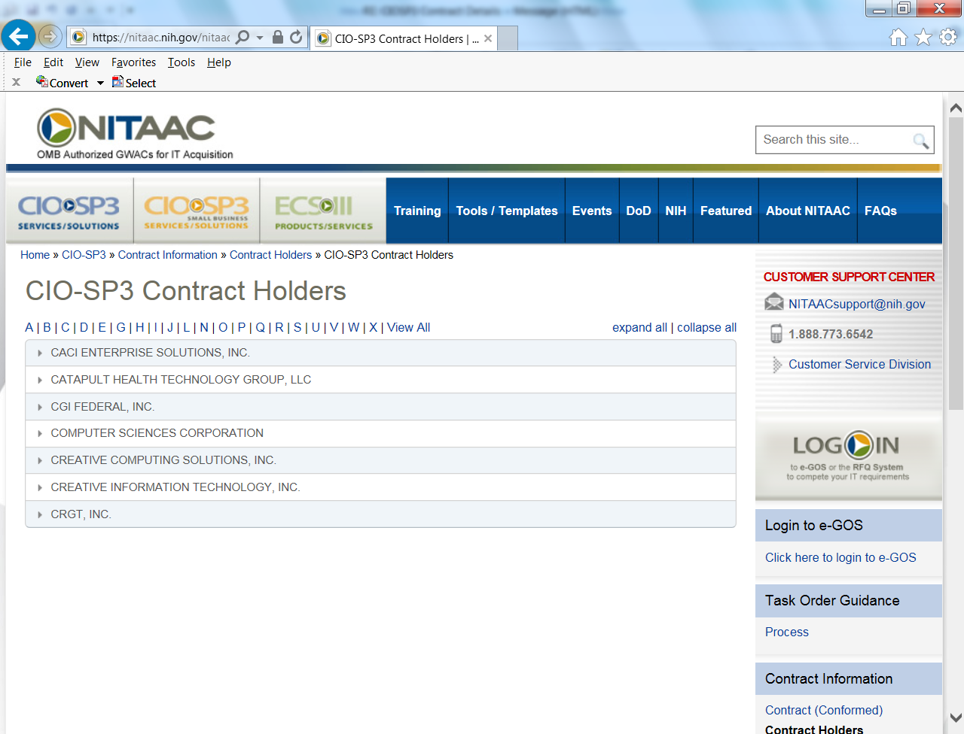

All CIO-SP3 contract holder on-and off-site rates can be obtained by logging into e-GOS. You can also visit the contract holder information page at http://nitaac.nih.gov/nitaac/contracts/cio-sp3/contract-holders, select the contract holder whose rates you want to see, and click the link to their individual websites.

